**GAMEPLAY DOCUMENT**

**FOR KERA**

Date : February 20th 2017

Version : 1.0

Written by : Phéçale LAFIA

SUMMARY

**IV-REANIMATION** 2

**V-CONTROLS** 2

# **IV-REANIMATION**

Reanimation is an important mechanism of the game. When a user loses the HP of his character, the character enters "suspended" mode. This means that the character is still alive but unable to defend himself.

He still has a certain time of reprieve that allows him to stay alive while a teammate wants to resuscitate him. When a character falls 2 consecutive times in the phase of suspended during a mission and is resuscitated in extremis, the third time, he dies and he will have to reappear.

The default time for suspended mode is 12 seconds. It’s during these 12 seconds that the user will hope to stay alive. The user can also extend this time by reducing his bleeding through the action "STAY IN LIFE".

Reanimation gives the player 25% of his HP. And it can be treated, only Lynna Wyse

• Only human characters can be cared by Lynna.

• The robot can only be cared for by Allyn Artjem.

• All characters can resurrect each other.

# **V-CONTROLS**

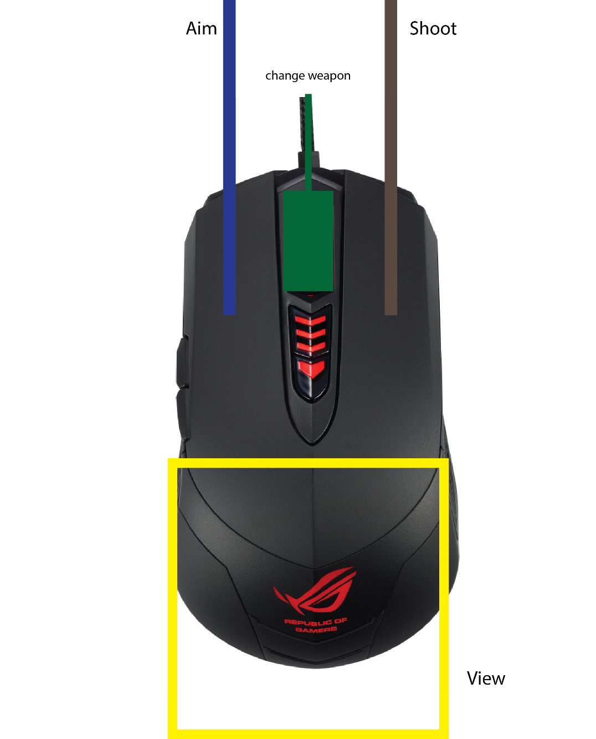

|  |  |
| --- | --- |
| Buttons | Actions |
| Right click | Aim |
| Left click | Shoot |
| Wheel | Change weapon |

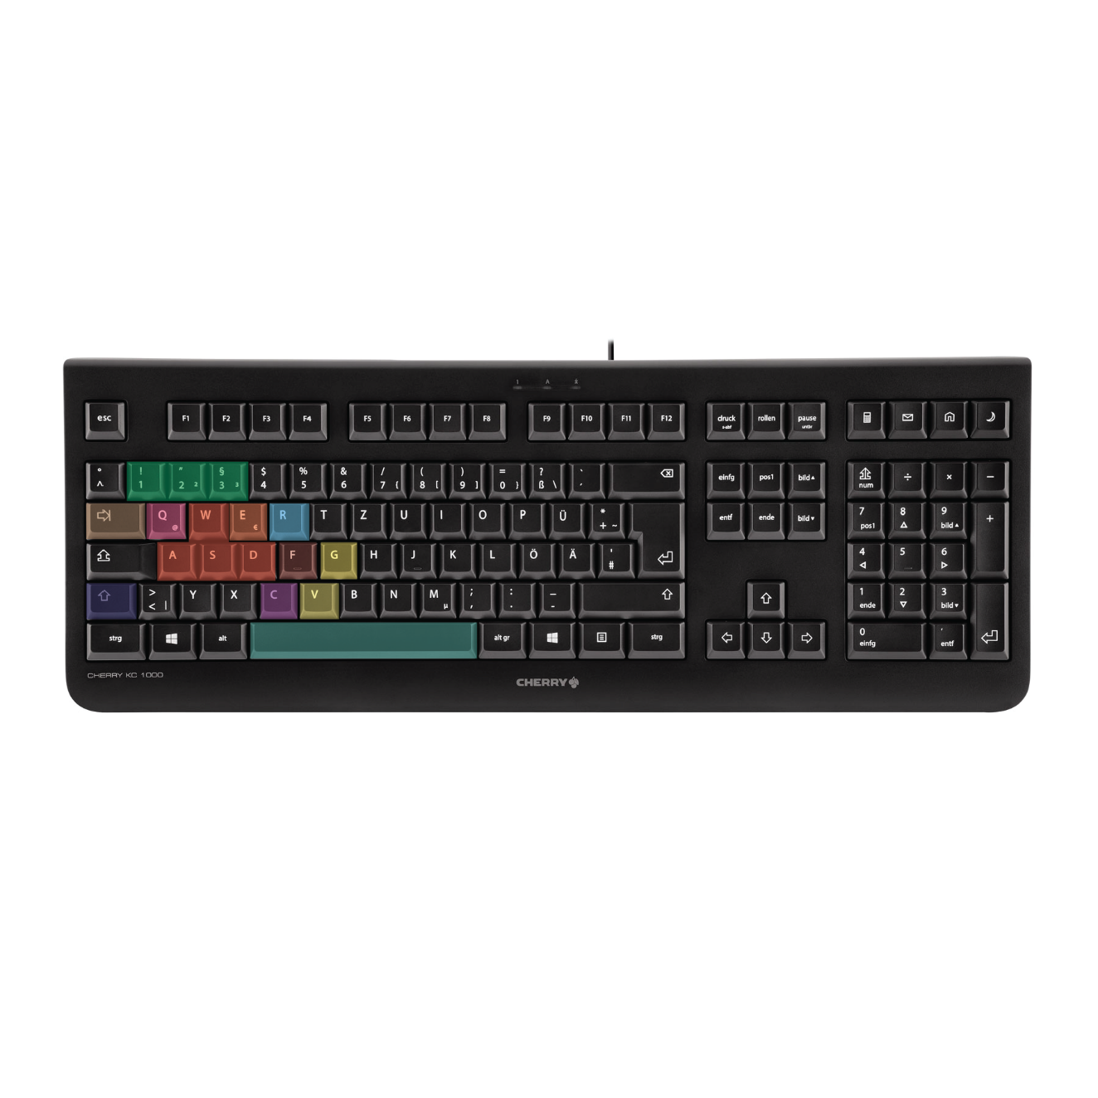

|  |  |
| --- | --- |
| Buttons | Actions |
| WASD/ZQSD | Moving the character |
| A/Q | Communication wheel (We will detail this soon) |
| E | Melee attack |
| R | Reload |
| Tab | Inventory |
| ESCAPE | Pause. But it's useless because the game continues. |
| F | Action key. Validate an action (pick up, use, buy, sell, etc.) |
| G | Grenades |
| 1-2-3 | Switch weapons |
| V | Special skill |
| C | Crouch |
| Spacebar | Jump |
| Shift | Run |